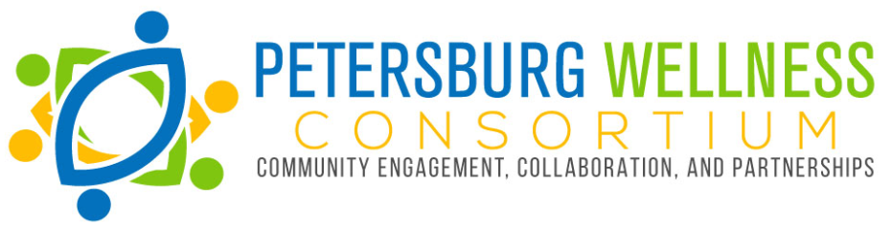
2019 Registration
Individual fee: $10
Organization fee: $25
Date:
Name:
Are you participating as an (circle one):
Individual member Organizational representative
Organization name:
Each organization is allowed one voting member at the annual meeting. Are you the voting member for your organization? Yes No
E-mail:
Phone:
Address:

Please circle which PWC workgroup you will participate in (circle one):
Chronic Disease
Oral Health
Youth Health and Wellness

Please note only checks will be accepted at this time and should be made out to: Pathways, Inc.
Please include PWC in the memo line.
Submit in person (to the PWC Treasurer), or mail to:
PO Box 2410
Petersburg, VA 23804

